Day 3: Cloud to Device

* Controlling Actuators
* Status Indicator
* Warning and Alert
* Power Electric device
* Sending command from Cloud to Device
* Responding to acknowledgement

Controlling Actuators

1. LED Status indicator
2. Motor (Fan)
3. Buzzer (Warning & Alert)
4. Relay (Control Electric)

LED Status indicator

1. 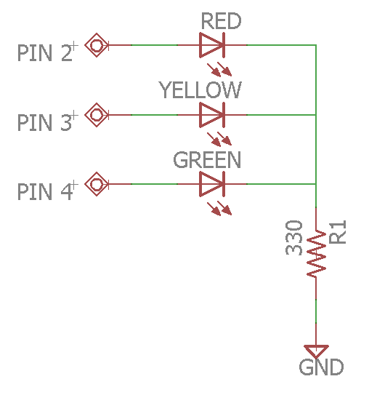Blink 3 LEDs.
2. Control blink speed.
3. Control blink speed 3 LEDs.
4. Control LED brightness.
5. Create WinForm with 3 buttons to display status and control 3 LEDs
6. Control blink speed from C#
7. Control blink speed each LED C#
8. Control brightness from C#

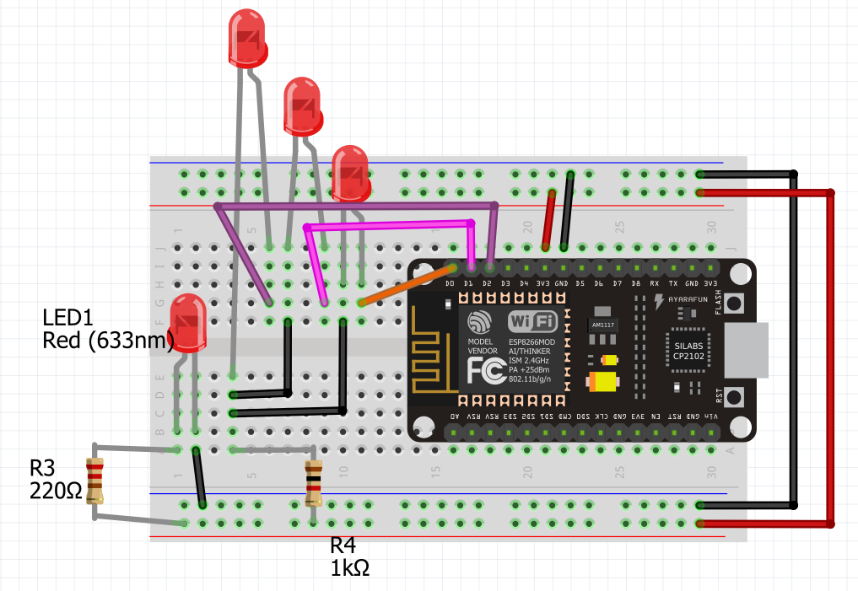

Motor (Fan)

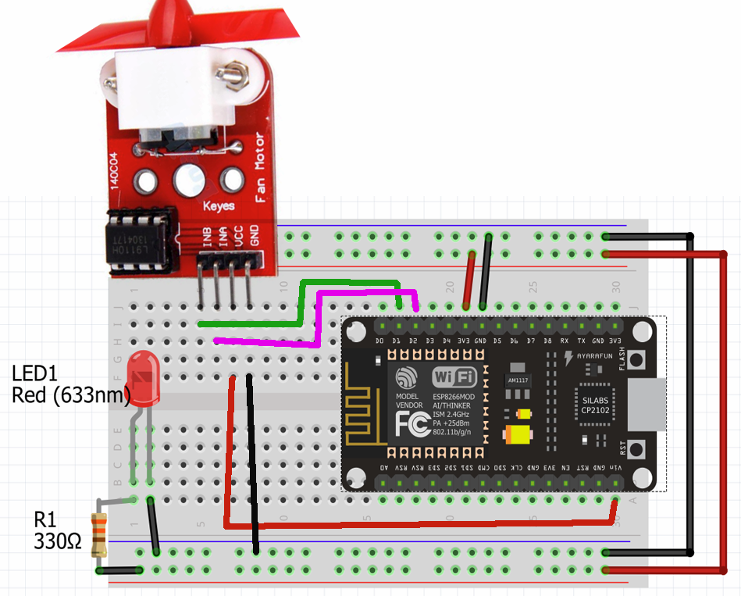

* InA = Pin D1
* InB = PinD2
* VCC = 5+
* GND = Ground

Fan1: Basic Code

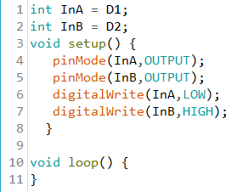

Fan2: Speed Control

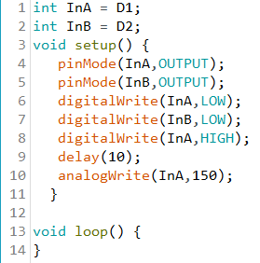

Fan3: Fan speed control from C#

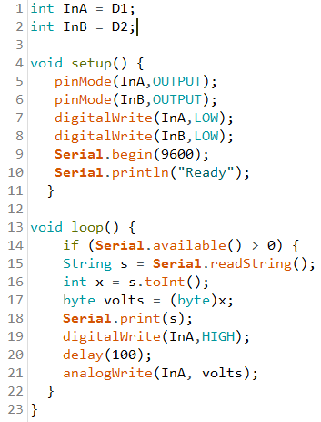

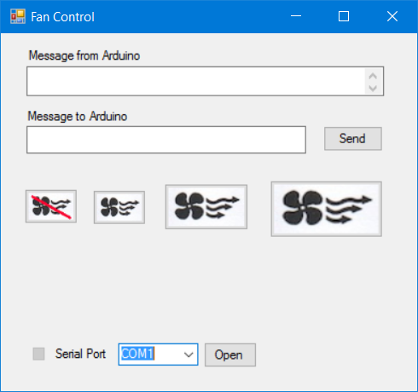

Buzzer (Warning & Alert)

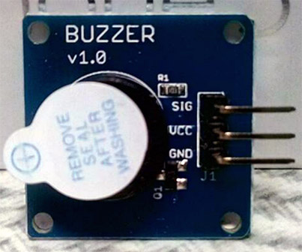

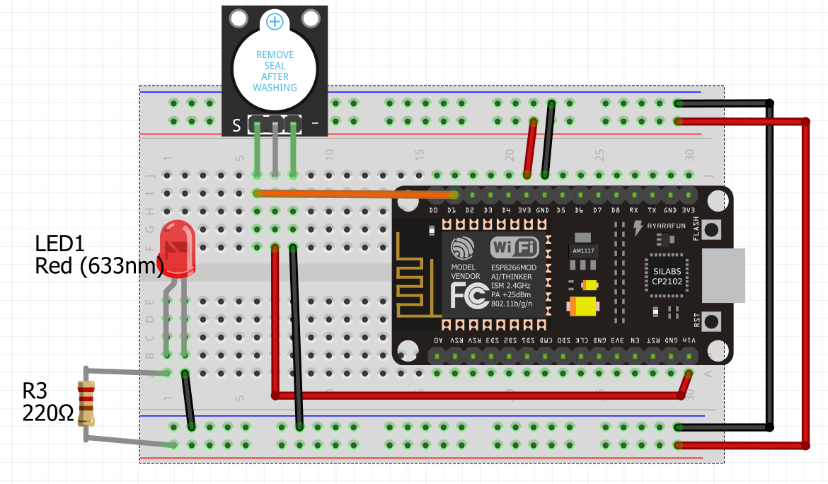

* SIG = D1
* VCC = 5V
* GND=GND

Buzzer Lab

1. Send SOS Morse code very 5 sec
2. Alarm when the temperature reach the certain point



Relay (Electric control)

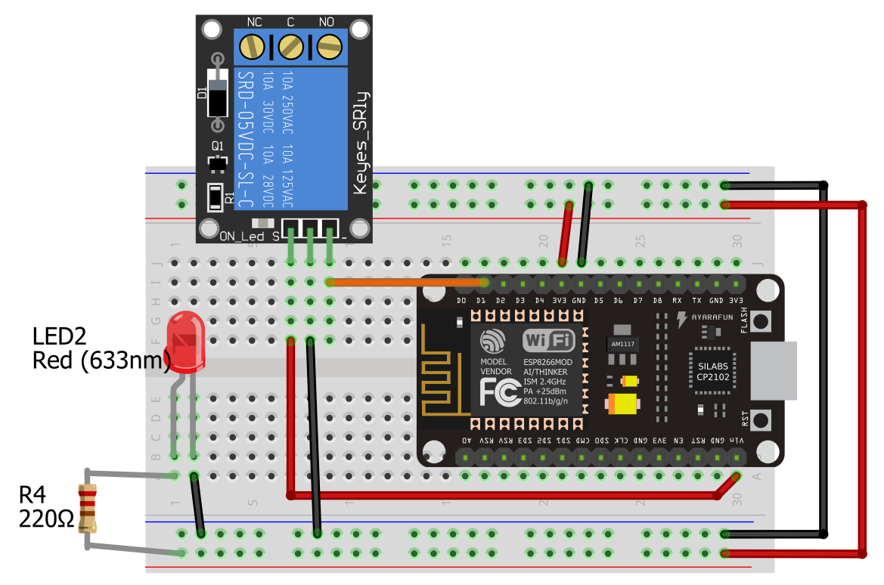

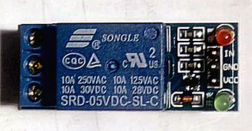

* IN = D1
* VCC = 5V
* GND = GND

Electrical hazard

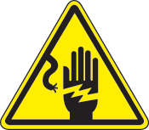





Arduino electric control schematic diagram

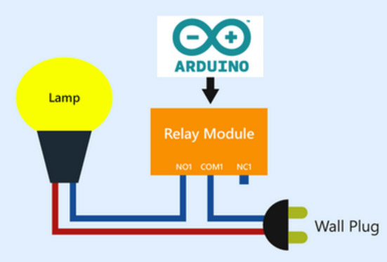

Relay Lab

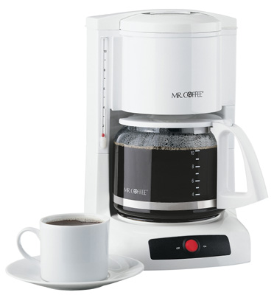

1. Turn the light on when it is dark
2. Turn on the coffee machine at 7:30 AM

Sending command from Cloud to Device

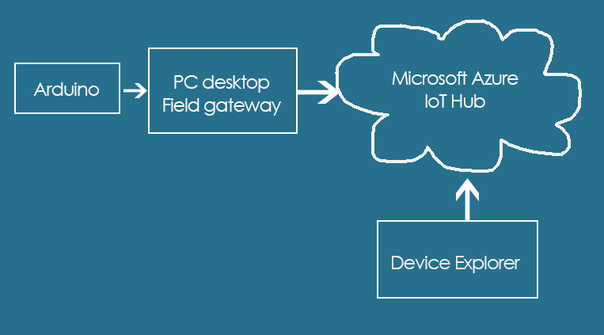

Receive message from Cloud

1. Create C# WinApp
2. Add Nuget “Microsoft.Azure.Devices.Client” package
3. Add TextBox
4. Add code
5. Use Device Explorer to send test message
6. If receive message “On” turn on LED
7. When receive message “Off” turn on LED

Testing Receive message from Cloud

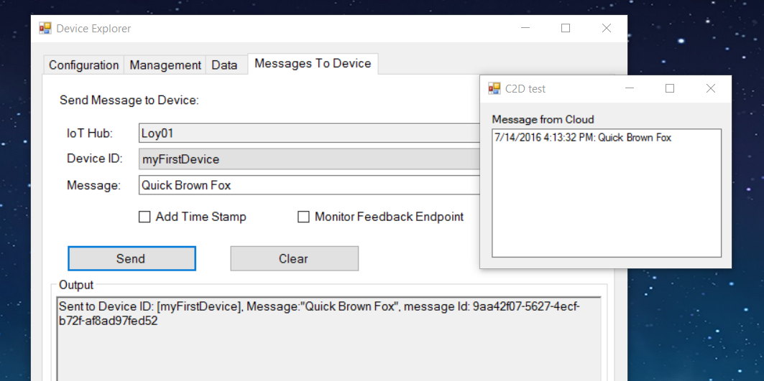

Create C# App to send C2D message

1. Create C# WinForm
2. Add NuGet “Microsoft Azure Devices” package

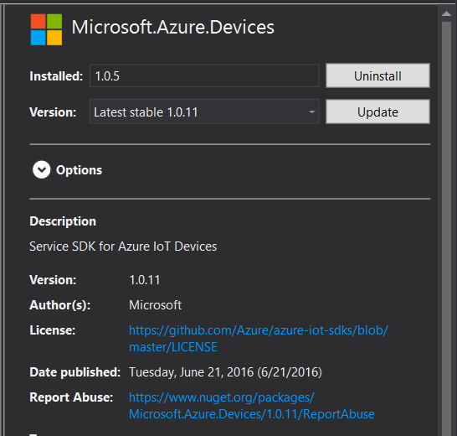

1. Add TextBox name = “textBoxC2D” to Form1 and a button

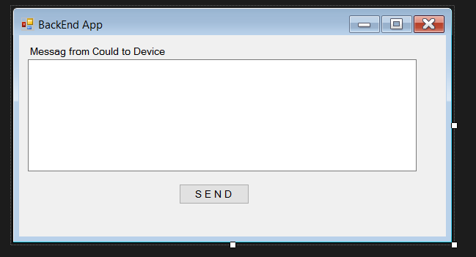

1. Add Name space to Form1

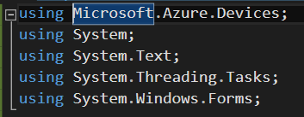

1. Add Class fields and method SendCloudToDeviceMessageAsync()

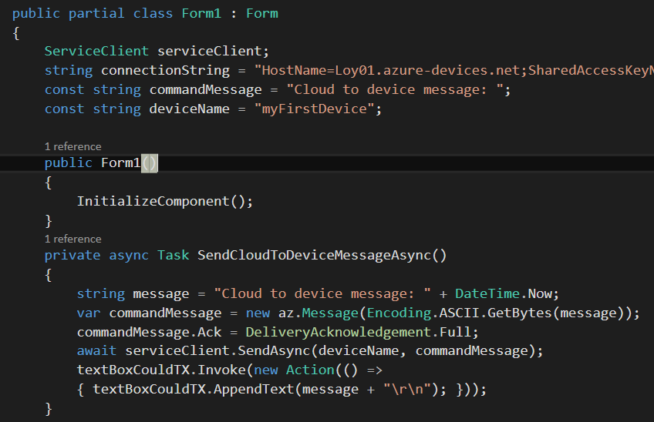

1. Add Form_Load and buttonSend_Click code

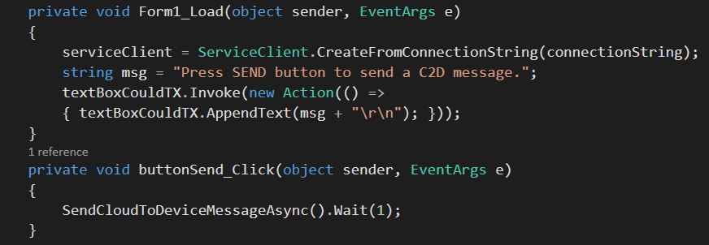

1. Test Program
   1. Run Program Receive message from Cloud (p415)
   2. Run Program send C2D (p417)
   3. Click send button

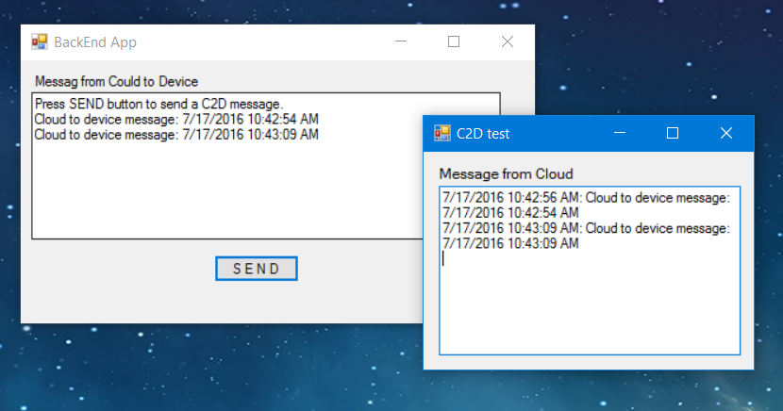

C2D Lab

1. Send message Normal, Warning or Alarm to device from cloud. Device shows status using LED normal = green, alarm = yellow, alarm = red
2. Send command from cloud to turn on the Fan when Temperature reaches a certain point
3. Send command from cloud to Buzz Alarm when detect a movement

Responding to acknowledgement

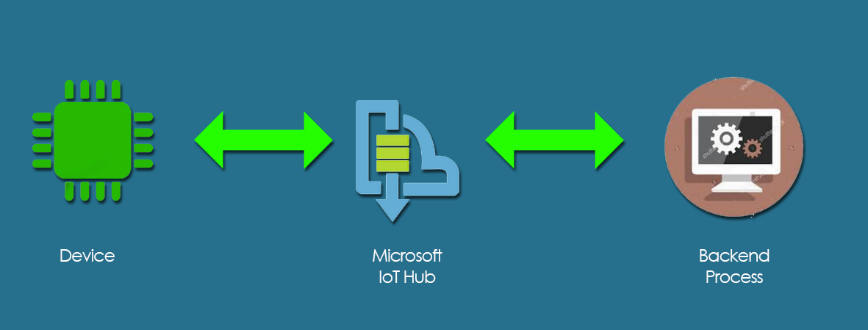

Run device simulator

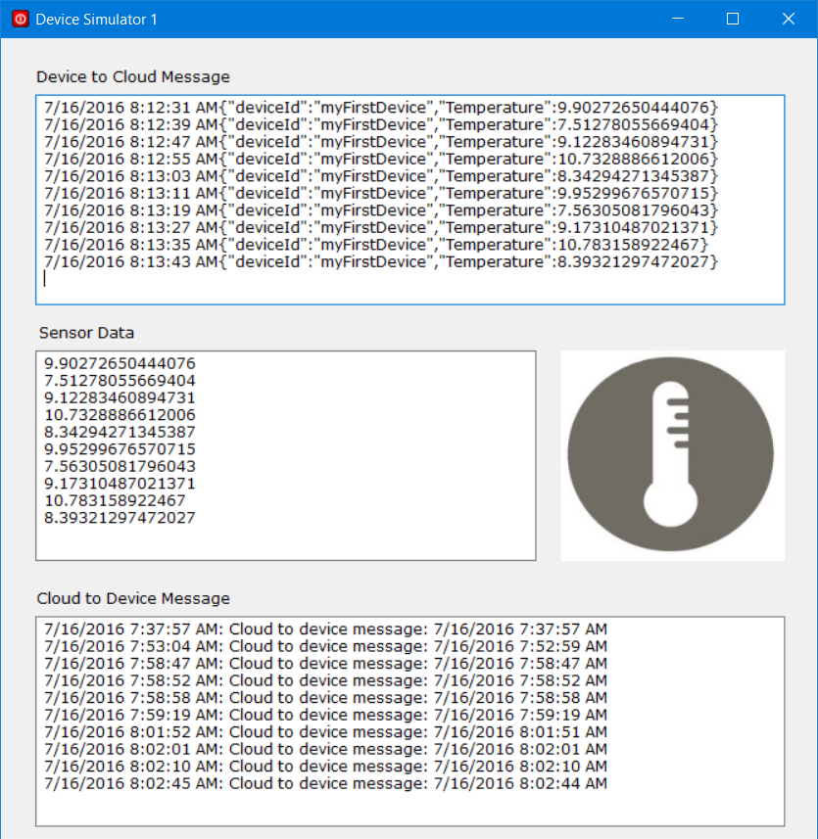

Create and Run Backend App

(modify from p417 WinApp)

